Name: Kalaiyarasan.K(20EE039)

Department : EEE

**Task:**

To Select and insert a element from the database using query in java coding and retrieve the data.

**Code:**

**import** java.sql.*;  
  
**public class** Database_creation{  
**public static void** main(String[] args) **throws** ClassNotFoundException, SQLException{  
insertQuery();  
selectQuery();  
 }  
**static void** insertQuery() **throws** ClassNotFoundException,SQLException  
{  
Class.forName("com.mysql.cj.jdbc.Driver");  
System.out.println("Driver class Loaded");  
Connection con = DriverManager.getConnection("jdbc:mysql://localhost:3306/ATM_DATABASE", "root", "Kalai2611@");  
System.out.println("Connected");  
Statement s = con.createStatement();  
System.out.println("Statement Object Created");  
  
**int** n= s.executeUpdate("insert into ATM(id,name,AMOUNT) values(3,\"vishnu\",4000);");  
 }  
**static void** selectQuery() **throws** ClassNotFoundException,SQLException  
{  
Class.forName("com.mysql.cj.jdbc.Driver");  
System.out.println("Driver class Loaded");  
Connection con = DriverManager.getConnection("jdbc:mysql://localhost:3306/ATM_DATABASE", "root", "Kalai2611@");  
System.out.println("Connected");  
Statement s = con.createStatement();  
System.out.println("Statement Object Created");  
  
ResultSetrs= s.executeQuery("select * from ATM_DATABASE.ATM");  
  
**while**(rs.next()){  
System.out.println(rs.getString(1)+" "+rs.getString(2)+" "+rs.getString(3));  
 }  
  
  
 }  
}

**Output :**

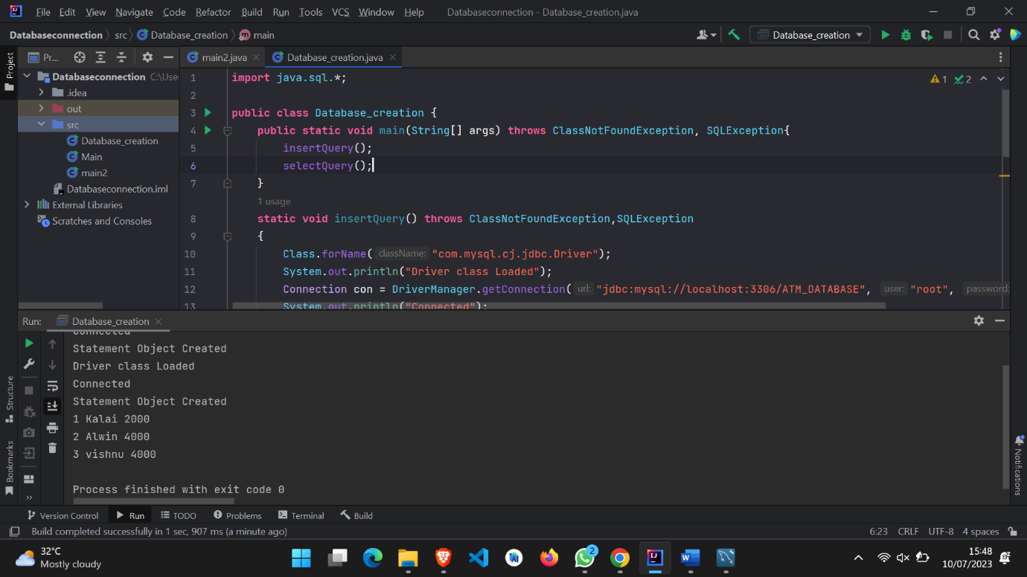

**After Insertion :**

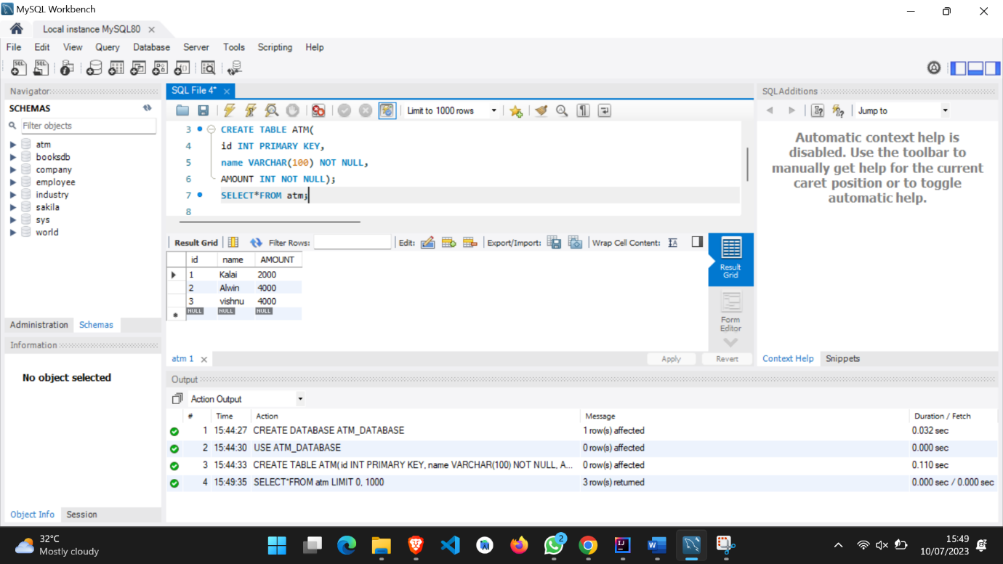

**Github Link:**

**https://github.com/kalaiyarasan2/kalai2611**